Title:- E-COMMERCE WEBSITE

Submited by:-

Preetham chowdary

14BCE0866

Slot:E2+TE2

Prof:- manoov sir

ABSTRACT:-

This project is a web based shopping system for an existing shop.

The project objective is to deliver the online shopping website.

This project is an attempt to provide the advantages of online shopping to

customers of a real shop. It helps buying the products in the shop

anywhere through internet. Thus the customer will get the service of online

shopping and home delivery from his favorite shop. This system can be

implemented to any shop in the locality or to multinational branded

shops having retail outlet chains.

If shops are providing an online portal where their customers can enjoy

easy shopping from anywhere, the shops won’t be losing any more

customers to the trending online shops such as flipcart or ebay.

objective:-

In the proposed system customer need not go to the shop for

buying the products. He can order the product he wish to buy through the

website. The shop owner will be admin of the

system. Shop owner can appoint moderators who will help owner in

managing the customers and product orders. The system also

recommends a home delivery system for the purchased products.

MANAGE USER

1. View Users:-

The admin will have a list view of all the users registered in the system.

Admin can view all the details of each user in the list except password.

2. Add Users:-

Admin has privileges to add a user directly by providing the details.

3. Delete &Block Users:-

Administrator has a right to delete or block a user. The default status of a

new user registered is set as blocked. The admin must accept the new

user by unblocking him.

MANAGE ORDERS:-

1. View Order:-

Administrator can view the Orders which is generated by the users. He

can verify the details of the purchase.

2. Delete order:-

Admin can delete order from the orders list when the product is taken for

delivery.

MANAGE PRODUCTS:-

1. Add Products:-

The shopping cart project contains different kind of products. The products

can be classified into different categories by name. Admin can add new

products into the existing system with all its details including an image.

2. Delete Products:-

Administrator can delete the products based on the stock of that particular

product.

3. Search products:-

Admin will have a list view of all the existing products. He can also search

for a particular product by name.

USERS:-

1. Registration:-

A new user will have to register in the system by providing essential

details in order to view the products in the system. The admin must accept

a new user by unblocking him.

2. Login:-

A user must login with his user name and password to the system after

registration.

3. View Products:-

User can view the list of products based on their names after successful

login. A detailed description of a particular product with product name,

products details, product image, price can be viewed by users.

4. Search Product:-

Users can search for a particular product in the list by name.

5. Add to cart:-

The user can add the desired product into his cart by clicking add to cart

option on the product.

He can view his cart by clicking on the cart button. All products added by

cart can be viewed in the cart. User can remove an item from the cart by

clicking remove.

6. Submit Cart:-

After confirming the items in the cart the user can submit the cart by

providing a delivery address.On successful submitting the cart will become

empty.

7. History:-

In the history the user will have a view of pending orders.

8. Edit Profile:-

The user can view and edit the profile.

USER:-

1. USER LOGIN:-

Description of feature:-

This feature used by the user to login into system. A user must login

with his user name and password to the system after registration. If they

are invalid, the user not allowed to enter the system.

Functional requirement:-

- Username and password will be provided after user registration is

confirmed.

- Password should be hidden from others while typing it in the field

2. REGISTER NEW USER:-

Description of feature:-

A new user will have to register in the system by providing essential

details in order to view the products in the system. The admin must accept

a new user by unblocking him.

Functional requirement:-

- System must be able to verify and validate information.

- The system must encrypt the password of the customer to provide

security.

3. PURCHASING AN ITEM:-

Description of feature:-

The user can add the desired product into his cart by clicking add to cart

option on the product. He can view his cart by clicking on the cart button.

All products added by cart can be viewed in the cart. User can remove an

item from the cart by clicking remove. After confirming the items in the cart

the user can submit the cart by providing a delivery address. On

successful submitting the cart will become empty.

Functional requirement:-

- System must ensure that, only a registered customer can purchase

items.

ADMIN:-

1. MANAGE USER:-

Description of feature:-

The administrator can add user, delete user, view user and block user.

2. MANAGE MODERATOR:-

Description of feature:-

The administrator can add moderator, delete moderator, block moderator

and search for a moderator.

3. MANAGE PRODUCTS:-

Description of feature:-

The administrator can add product, delete product and view product.

4. MANAGE ORDERS:-

Description of feature:-

The administrator can view orders and delete orders.

Functional requirements:-

-The system must identify the login of the admin.

Online Shopping System

Department of Computer Science, CUSAT Page 32

-Admin account should be secured so that only owner of the shop can

access that account

Database:-

Databases are the storehouses of data used in the software systems. The

data is stored in tables inside the database. Several tables are

created for the manipulation of the data for the system. Two essential

settings for a database are

primary key- the field that is unique for all the record occurrences.

foreign key- the field used to set relation between tables.

Normalization is a technique to avoid redundancy in the tables.

FRONT END:-

JSP, HTML, CSS, JAVA SCRIPT are utilized to implement the

frontend.

1. Java Server Pages (JSP):-

Different pages in the applications are designed using jsp. A Java Server

Pages component is a type of Java servlet that is designed to fulfil the role

of a user interface for a Java web application. Web developers write JSPs

as text files that combine HTML or XHTML code, XML elements, and

embedded JSP actions and commands. Using JSP, one can collect input

from users through web page.

2. HTML (Hyper Text Markup Language):-

HTML is a syntax used to format a text document on the web.

3. CSS (Cascading Style Sheets):-

CSS is a style sheet language used for describing the look and

formatting of a document written in a markup language.

4. Java Script:-

JS is a dynamic computer programming language. It is most commonly

used as part of web browsers, whose implementations allow client-side

scripts to interact with the user, control the browser, communicate

asynchronously, and alter the document content that is displayed.

Java Script is used to create pop up windows displaying different alerts in

the system like “User registered successfully”, ”Product added to cart” etc.

BACK END:-

The back end is implemented using MySQL which is used to design the

databases.

MySQL:-

MySQL is the world's second most widely used open-source relational

database management system (RDBMS). The SQL phrase stands for

Structured Query Language.

An application software called Navicat was used to design the tables in

MySQL.

TABLES:-

1. LOGIN:-

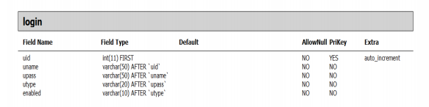

2. USER DETAILS:-

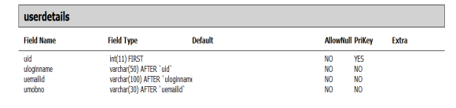

3. PRODUCT DETAILS:-

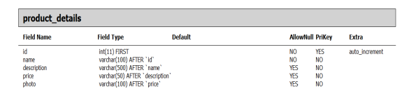

4. PRODUCT ORDERS:-

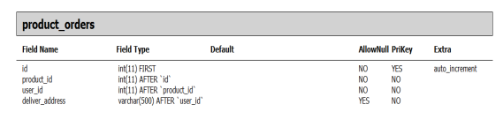

5. COMPLETE DIAGRAM-

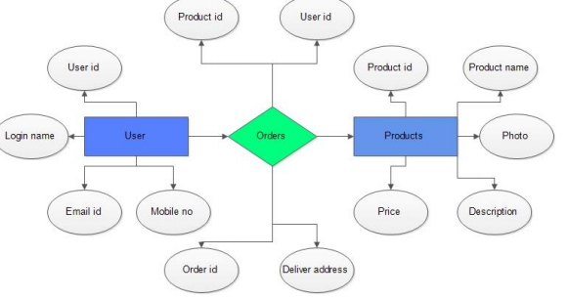

CONCLUSION:-

The central concept of the application is to allow the customer to shop virtually using the Internet and allow customers to buy the items and articles of their desire from the store. The information pertaining to the products are stores on an RDBMS at the server side (store).

The Server process the customers and the items are shipped to the address submitted by them. The application was designed into two modules first is for the customers who wish to buy the articles. Second is for the storekeepers who maintains and updates the information pertaining to the articles and those of the customers. The end user of this product is a departmental store where the application is hosted on the web and the administrator maintains the database. The application which is deployed at the customer database, the details of the items are brought forward from the database for the customer view based on the selection through the menu and the database of all the products are updated at the end of each transaction. Data entry into the application can be done through various screens designed for various levels of users. Once the authorized personnel feed the relevant data into the system, several reports could be generated as per the security.